
Saint Michael College, Cantilan, Incorporated
Cantilan, Surigao del Sur
College Department

LEARNING MODULE
in FS II

- MODULE 4: INSTRUCTIONAL STRATEGIES

- LEARNING ACTIVITIES (Use long bond papers.)
View and observe the classes. Write a narrative observation report on how teachers are using the different teaching strategies in their class.

1) Constructivist Teaching
Video:
Subject: Science
Topic: Living and Nonliving Things
Observation:
During the lesson, the teacher used a constructivist approach by allowing the Grade 2 learners to explore pictures of different objects and classify them based on their prior knowledge. Instead of directly giving the answers, Teacher Christy encouraged students to share their ideas first by asking, “What do you notice?” and “Why do you think this is living?” Students constructed their own understanding as they observed, discussed, and justified their answers. The teacher guided them by providing prompts and clarifying misconceptions, allowing students to build learning from their experiences and observations. The activity promoted active participation, curiosity, and ownership of learning.

2) Differentiated Learning
Video:
Subject: Science
Topic: Parts of a Plant
Observation:
Teacher Christy used differentiated instruction to meet the diverse needs of Grade 2 learners. She prepared three types of tasks: drawing the parts of a plant for visual learners, labeling a picture for those who prefer structured tasks, and a hands-on activity using real plants for kinesthetic learners. She grouped the students according to their learning readiness and provided appropriate support for each. Fast learners were given an extension activity, while struggling learners received guided assistance. This strategy ensured that every child could learn at their own pace and ability level.

3) Integrated Teaching and Learning
Video:
Subject: Science
Topic: Weather and Clothing
Observation:
The teacher integrated Science with other subjects such as Math and English. Students identified different weather conditions and matched them with appropriate clothing. For English integration, students described why certain clothes are used during sunny or rainy days using simple sentences. For Math, they counted and sorted clothing items based on the type of weather. This integration helped students see the connection between lessons and real-life situations, making learning more meaningful, holistic, and enjoyable.

4) Cooperative Learning
Video:
Subject: Science
Topic: States of Matter: Solid, Liquid, Gas
Observation:
Cooperative learning was demonstrated through group activities where students worked together to sort objects into solid, liquid, and gas categories. Each group was assigned roles such as leader, writer, and presenter to encourage participation. The students discussed their ideas and agreed on the correct classification before presenting. Teacher Christy walked around to facilitate, but the students were responsible for teamwork and decision-making. This strategy developed communication, cooperation, and social skills.

5) Problem – based Learning
Video:
Subject: Science
Topic: How to Keep the Environment Clean
Observation:
The teacher presented a real-life problem: “Our school garden is full of scattered trash. What can we do to keep our environment clean?” Students worked in groups to propose solutions. They brainstormed ideas such as proper waste segregation, placing trash bins, recycling materials, and doing regular clean-ups. Each group presented their action plan. The teacher guided them in evaluating which solutions were practical and environmentally friendly. This approach helped students develop critical thinking, creativity, and responsibility toward their environment.

Examine: Complete the table below using the date you have gathered.

Teaching Strategy | Challenges met by teachers in the implementation of the teaching strategy | How does the strategy improve students’ learning?
Constructivist Teaching | Some learners struggle to express their ideas; limited vocabulary in English; requires more time since students build their own understanding. | Helps students develop critical thinking, encourages exploration, strengthens understanding through discovery, and allows them to connect lessons to real-life experiences
Differentiated Learning | Time-consuming to prepare varied activities; difficult to manage multiple tasks at once; students have different pacing which needs extra monitoring. | Addresses diverse learning needs, supports struggling learners, challenges advanced learners, and helps each child learn at their own level and ability.
Integrated Teaching and Learning | Hard to connect subjects when time is limited; students may get confused if too many subjects are mixed; requires extra planning and creativity. | Makes learning meaningful, helps students see connections between subjects, improves comprehension, and promotes holistic learning.
Cooperative Learning | Some students dominate while others stay quiet; noise level increases during group work; requires constant supervision to maintain focus. | Enhances teamwork, communication, and social skills; helps shy learners participate; encourages peer teaching and shared responsibility.
Problem-based Learning | Students may struggle to think of solutions independently; requires strong guidance; may take longer to finish; some learners get confused without clear steps. | Builds problem-solving and decision-making skills, improves creativity, promotes real-life application of concepts, and encourages deeper understanding.

- SELF-EVALUATION

Reflection
• I realized that
teaching requires creativity, patience, and flexibility, especially when using different teaching strategies. I saw how each learner has unique needs and how important it is to adjust my methods to help all students understand the lesson. I also realized that effective teaching is not just about giving information, but guiding students to explore, think, and discover learning on their own.

• I believe it is essential to
use a variety of strategies such as constructivist teaching, differentiated learning, cooperative learning, and problem-based learning to ensure that every child has the opportunity to learn meaningfully. It is important to consider students’ readiness, abilities, and interests so that lessons become engaging and easy to understand. By doing this, students become more active, motivated, and confident in their learning.

• From now on, I am determined to
improve my teaching practices by planning lessons that are learner-centered and developmentally appropriate. I will continue observing experienced teachers like Teacher Christy and apply the strategies I learned in my Grade 2 Science class. I am committed to becoming more resourceful, reflective, and intentional in helping my learners succeed.

- TEST : Write your answer in a long bond paper.

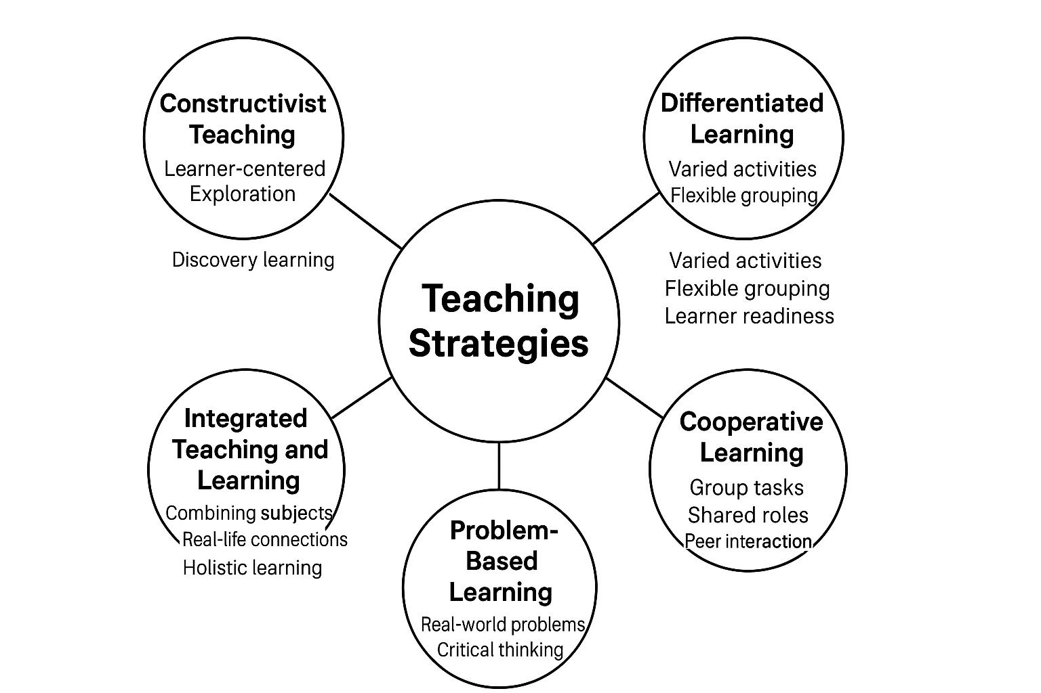
- Construct a graphic organizer of different teaching strategies.

- How should cooperative learning be done effectively in teaching?
Cooperative learning should be done effectively by organizing students into small, balanced groups where each member has a specific role such as leader, recorder, or presenter. The teacher must clearly explain the task, expected output, and rules for working together to ensure that students understand their responsibilities. During group activities, the teacher should monitor each group, provide guidance, and ensure that all students are participating and communicating respectfully. It is also important to set positive group norms where students listen to one another, share ideas, and support their classmates. After completing the activity, each group should be given time to present their work and reflect on their teamwork. By following these steps, cooperative learning becomes more meaningful, engaging, and effective in helping students develop academic understanding as well as social and communication skills.

